**AI Content Detector**

Submitted in partial fulfilment of the requirements

Of the degree of

Bachelor of Engineering in Information Technology

By

**Khan Ejaj Ahmed**

(211416)

**Khan Talha**

(211419)

**Khan Imran**

(211417)

# Yadav Jaideep

# (211457)

Guide:

# Er. Shridnidhi Gindi



Department of Information Technology

**M.H. SABOO SIDDIK COLLEGE OF ENGINEERING**

(2024-2025)

# CERTIFICATE

This is to certify that the project entitled ***“AI Content Detector”***is bonafidework of *“****Khan Ejaj Ahmed*** *(211416),* ***Khan Talha*** *(211419),* ***Khan Imran*** *(211417),* ***Yadav Jaideep*** *(211457)”* Submitted to the University of Mumbai in partial fulfillment of therequirement for the award of the degree of “**Bachelor of Engineering (Information Technology**)”.

**Er. Shridnidhi Gindi**

Guide

**Dr. Zainab Mirza** **Dr. Ganesh Kame**

Head of Department I/C Principal

**PROJECT REPORT APPROVAL FOR B.E.**

This project report entitled **“AI Content Detector”** by “**Khan Ejaj Ahmed** (211416), **Khan Talha** (211419), **Khan Imran** (211417), **Yadav Jaideep** (211457)” is approved for the degree of **Bachelor of Engineering** in **Information Technology**.

Examiners

1. ____________________

1. ____________________

Date:

Place: Mumbai

# DECLARATION

We declare that this written submission represents our idea in our own words and where other’s idea or words have been included, we have adequately cited and referenced the original sources. We also declare that, we have adhered to all principles of academic honesty and integrity and have of misrepresented or fabricated or falsified our idea/fact/source in our submission. We understand that any violation of the above will be caused for disciplinary action by the institute and can also invoke panel action from the sources which have thus not been properly cited or from whom proper permission has not been taken when needed.

1. ____________________________________

(Khan Ejaj Ahmed 211416)

1. ____________________________________

(Khan Talha 211419)

1. ____________________________________

(Khan Imran 211417)

1. ____________________________________

(Yadav Jaideep 211457)

Date:

Place: Mumbai

## ACKNOWLEDGEMENT

A project is never the outcome of a single person’s effort. It is the confluence of varied thought process harmoniously integrated into resourceful product. It is natural that we feel indebted to several people having made this project possible.

We wish to express our gratitude to our parents who have been the major contributor of inspiration and encouragement to us throughout our career.

We wish to express our heartfelt and sincere gratitude to our principal **Dr. Ganesh Kame**, M.H. Saboo Siddik College of Engineering, Mumbai for providing the facilities to carry out our project work.

We wish to express our grateful thanks to beloved Head of Department of Information Technology **Dr. Zainab Mirza**, who gave us full support and her constant encouragement, valuable suggestions and helping tendency which made us to carry out the project work.

We wish to express gratitude to our guide **Er. Shridnidhi Gindi** for valuable suggestions and their helping tendency which made us to carry out our project work successfully. Our thanks to all our faculty and non-teaching staff members of our department for their support and peers for having stood by to complete this project.

## ABSTRACT

The rise of AI-generated content, particularly from models like ChatGPT, poses significant challenges to academic integrity and raises concerns about plagiarism. This study investigates the effectiveness of **AI content detection** tools in distinguishing between human and AI-authored text, finding that these tools are more accurate with **GPT-3.5 than GPT-4**. However, inconsistencies arose when evaluating human-written responses, resulting in false positives and uncertain classifications. This underscores the necessity for ongoing refinement of detection tools as AI-generated content becomes increasingly sophisticated. The project aims to develop a machine learning model to enhance content reliability and authenticity for educators, journalists, and content moderators. Utilizing Python, Jupyter Notebook, and VS Code for coding and data visualization, the development will employ key libraries like Transformers for natural language processing and Torch for deep learning. **RoBERTa**, an optimized variant of BERT, will be used to improve performance through advanced training methods on a balanced dataset comprising both human and AI-generated content. This initiative is crucial for maintaining integrity in education and ensuring source verification in journalism.

## Table of Contents

|  |  |  |
| --- | --- | --- |
| **Sr. No.** | **Content** | **Page No.** |
|  | Certificate | i |
|  | Project Report Approval for B.E. | ii |
|  | Declaration | iii |
|  | Acknowledgement | iv |
|  | Abstract | v |
|  | Table of Content | vi-vii |
|  | List of Figures | viii |
|  | List of Tables | ix |
| **Sr. No.** | **Chapter Title** | **Page No.** |
| 1 | **Introduction** | **1-4** |
|  | 1.1 Overview of AI Content Detection Systems | 1 |
|  | 1.2 Aim of the Project | 2 |
|  | 1.3 Objectives | 2-3 |
|  | 1.4 Scope | 3-4 |
| 2 | **Literature Survey** | **5-8** |
|  | 2.1 Existing System | 5 |
|  | 2.2 Review of Research Papers | 7-8 |
|  | 2.3 Summary of Literature Review | 8-9 |
| 3 | **System Analysis and Design** | **10-17** |
|  | 3.1 Problem Definition | 10 |
|  | 3.2 System Architecture and Module Breakdown | 11-14 |
|  | 3.3 Classification Diagram & Working | 15-17 |
| 4 | **System Requirements** | **18-18** |
|  | 4.1 Software Requirements | 16 |
|  | 4.2 Hardware Requirements | 17 |
|  | 4.3 Technology Stack Used | 21 |
| 5 | **Implementation** | **21-25** |
|  | 5.1 Machine Learning Model Implementation | 21-22 |
|  | 5.2 Backend Implementation | 23-25 |
| 6 | **Results** | **26-30** |
|  | 6.1 Output Screens | 26-27 |
|  | 6.3 Testing Strategies | 28-30 |
| 7 | **Conclusion and Future Scope** | **31-33** |
|  | 7.1 Conclusion | 31 |
|  | 7.2 Future Scope | 32 |
| 8 | **Timeline Chart** | **33** |
| 9 | **References** | **34-35** |
| 10 | **Appendix** | **36-38** |
| 11 | **Research Paper Publication** | **39-47** |

## List of Figures

|  |  |  |
| --- | --- | --- |
| Figure No. | Caption | Pg. no. |
| 3.1 | System Architecture of Roberta | 12 |
| 3.2 | Classification Diagram | 15 |
| 6.1 | Home Page of AI Content Detection | 26 |
| 6.2 | Selecting File in AI Content Detection | 26 |
| 6.3 | Generated by Human Real | 27 |
| 6.4 | Generated by AI (Fake) | 27 |
| 8.1 | Timeline Chart (Gantt Chart) | 33 |

**List of Tables**

|  |  |  |
| --- | --- | --- |
| Table No. | Title | Pg. no. |
| 2.1 | Summary of Literature Survey | 8 |
| 3.1 | Module Breakdown Table | 10 |
| 4.1 | Development Requirements | 16 |
| 4.2 | Production Requirements | 16 |
| 5.1 | Key API Endpoints | 24 |
| 6.1 | Input Classification Test Cases | 28 |
| 6.2 | Document Upload and Parsing Testing | 28 |
| 6.3 | Model Inference and Response Testing | 29 |
| 6.4 | User Interface Test Cases | 30 |
| 10.1 | AI Content Detector model | 36 |
| 10.2 | Tools and Libraries Used | 37 |
| 10.3 | Acronyms and Terminologies | 38 |

## CHAPTER 1 INTRODUCTION

### 1.1 Overview of AI Content Detection Systems

In today’s digital era, artificial intelligence (AI) has significantly transformed the way content is generated and consumed. Tools such as **ChatGPT** and other **large language models (LLMs)** have enabled the creation of coherent, contextually relevant text at scale. While these advancements have brought about numerous benefits, they have also introduced challenges—particularly in the realm of authorship verification and academic integrity.

AI-generated content often mirrors the linguistic style and coherence of human writing, making it difficult to distinguish between the two. This overlap has raised concerns in academia, journalism, and digital media, where the authenticity and originality of content are crucial. Traditional plagiarism checkers, which were once sufficient to flag copied material, now fall short in detecting machine-generated text that is original yet synthetically authored.

In this context, the need for AI-powered content detection systems has become increasingly evident. These systems aim to analyze text using natural language processing (NLP) and machine learning (ML) to classify whether the content was generated by humans or AI. The “**AI Content Detector**” project addresses this growing need by building a robust, scalable, and accurate detection platform capable of keeping pace with evolving AI technologies like GPT-3.5 and GPT-4.

.

### 1.2 Aim of the Project

The primary aim of this project is to develop a machine learning-based content detection system that accurately **differentiates between human-written and AI-generated text**. The solution is designed to assist educators, journalists, and content moderators in evaluating the authenticity of digital content, thereby promoting trust, transparency, and integrity across various information-driven sectors.

By leveraging deep learning techniques, particularly the RoBERTa model, the system will be capable of analyzing complex linguistic patterns. The project also focuses on reducing false positives and enhancing classification confidence to ensure actionable and trustworthy results.

### 1.3 Objectives

The key objectives of the AI Content Detector system are:

* **To evaluate existing detection tools** and identify their limitations, particularly with the latest language models like GPT-4.
* **To develop a robust machine learning model** using natural language processing techniques and deep learning frameworks for content classification.
* **To utilize a balanced dataset** consisting of both AI-generated and human-written content, ensuring accurate training and testing.
* **To minimize false positives and misclassifications**, thereby improving the reliability of the system.
* **To provide an intuitive user interface** for educators, journalists, and content reviewers to analyze, review, and report the origin of text-based content.
* **To offer a scalable and secure detection platform** that can be integrated with other digital systems for real-time analysis and reporting.

By achieving these objectives, the project seeks to bridge the communication and operational gap between students and the examination authority while enabling data-driven academic decisions.

### 1.4 Scope

The **AI Content Detector** project is designed to address the increasing complexity and prevalence of AI-generated text in digital ecosystems. As AI writing models become more advanced, distinguishing between human and machine-authored content is becoming a critical task across multiple domains—including education, journalism, publishing, social media moderation, and corporate communications.

This project focuses specifically on **text-based content analysis**, targeting various forms such as essays, reports, blogs, news articles, and academic submissions. It aims to provide a comprehensive solution capable of **accurately classifying content origin** by leveraging state-of-the-art natural language processing (NLP) and deep learning techniques.

Key elements of the scope include:

* **Multi-format Input Handling**: The system supports both direct text input and document uploads (e.g., .docx, .pdf, .txt), ensuring flexibility and ease of use across different user needs and data sources.
* **Detection of Advanced AI Models**: The project emphasizes the need to detect outputs from cutting-edge AI systems like GPT-3.5 and GPT-4, which produce high-quality, contextually rich text. The detection model is fine-tuned to identify subtle linguistic patterns that differentiate such content from human writing.
* **User-Specific Applications**:
  + In **education**, it assists educators in maintaining academic integrity by flagging AI-generated assignments or reports.
  + In **journalism and media**, it helps verify the authenticity of articles, especially in an age of misinformation.
  + In **online platforms**, it supports moderators in managing spam, fake reviews, and bot-generated content.
* **Real-Time Analysis and Feedback**: The system is optimized to deliver fast, accurate results for live content evaluation. This makes it highly effective in scenarios where time-sensitive decisions are necessary.
* **Scalable Architecture**: Built with scalability in mind, the solution can be expanded to accommodate large-scale deployments across universities, editorial teams, or enterprise-level content management systems. Its modular design allows integration with other applications via APIs.
* **Security and Privacy**: User data, content submissions, and detection results are handled with strict confidentiality. The system employs encryption and secure storage mechanisms to protect sensitive data.
* **Data Logging and Report Generation**: The system maintains a historical log of analyzed content, providing downloadable reports that include classification results, confidence scores, timestamps, and analysis metrics. These logs can serve as digital proof for decision-making or audits.
* **Future-Proofing with Continuous Learning**: The model is designed to evolve through retraining on new datasets, enabling it to stay relevant as AI content generation methods advance. It can also be adapted for multilingual analysis or extended to other media types, such as audio or video transcripts.

## CHAPTER 2 LITERATURE SURVEY

### 2.1 Existing System

With the rise of **generative AI models** such as GPT-3.5 and GPT-4, the landscape of digital content creation has undergone a rapid transformation. While these models offer immense potential for creative and automated writing, they also introduce serious challenges regarding content authenticity and source verification.

Many current detection systems rely on heuristic-based approaches or shallow machine learning models that fail to keep pace with the evolving sophistication of language models. Tools such as OpenAI’s own content classifiers, **ZeroGPT**, and **GPTZero** provide initial layers of classification, but often lack consistent accuracy—especially when handling nuanced or well-crafted AI-generated content.

Furthermore, these systems typically suffer from the following limitations:

* **High false positive rates**, misclassifying human-written content as AI-generated.
* **Limited generalization**, with models performing inconsistently across writing styles and topics.
* **Low adaptability**, especially when facing updates or new AI models.

Given the increasing reliance on digital communication in **education, journalism, and business,** the demand for robust and scalable **AI content detection systems** has never been greater.

### 2.2 Review of Research Papers

To build an accurate and future-ready AI content detector, a comprehensive understanding of existing academic efforts and technological frameworks is essential. Several research studies and tools have contributed to the foundational knowledge and inspired the development of our solution.

**1. Effectiveness of Free Software for Detecting AI-Generated Writing**

* **Purpose**: Evaluates free AI detection tools used to identify AI-generated student assignments.
* **Techniques**: Comparative manual analysis and performance testing of tools such as GPTZero and OpenAI's classifier.
* **Findings**: Revealed significant limitations in accuracy, with a tendency to produce false positives for non-native English texts.
* **Drawback**: Lack of standardization and poor adaptability to newer AI models.

**2. Evaluating the Efficacy of AI Content Detection Tools**

* **Purpose**: Investigates how effectively existing tools detect content generated by GPT-3.5 vs. GPT-4.
* **Techniques**: Experimental analysis on a controlled dataset (engineering topics).
* **Findings**: Tools performed better with GPT-3.5 than GPT-4 but struggled with human-written content.
* **Drawback**: Detection inconsistency, especially for nuanced, fact-based human writing.

**RoBERTa-Based Models for Text Classification (2019–2023)**

* **Purpose**: Studies the effectiveness of RoBERTa in classification tasks, including fake news detection and spam classification.
* **Techniques**: Use of transformer architecture for contextual understanding of text.
* **Findings**: High accuracy and precision in content classification due to pre-training on large, diverse corpora.
* **Drawback**: Requires significant computational resources for fine-tuning and inference.

**4. Deep Fake Detection and Natural Language Watermarking**

* **Purpose**: Explores content traceability through cryptographic and watermarking techniques.
* **Techniques**: Embedding hidden signals in AI-generated content to aid detection.
* **Findings**: Effective in controlled scenarios.
* **Drawback**: Not applicable to existing AI outputs that lack embedded markers.

**5. DeepFakeEvaluating the Efficacy of AI Content Detection Tools in Differentiating Between Human and AI-Generated)**

* **Purpose**: Uses stylometric and semantic analysis to attribute authorship to written content.
* **Techniques**: Feature extraction (vocabulary richness, sentence length, syntactic variation).
* **Findings**: Useful in academic plagiarism detection.
* **Drawback**: Less effective with short or generic text samples.

### 2.3 Summary of Literature Review

|  |  |  |  |  |
| --- | --- | --- | --- | --- |
| **Paper Name** | **Author(s) & Year** | **Year** | **Findings** | **Drawbacks** |
| **Effectiveness of Free AI Detection Tools** | Gregory Price and Marc Sakellarios | 2023 | Highlighted the challenges educators face in detecting AI-generated writing.  It emphasized the need for cautious use of detection tools in educational settings, as they may not provide definitive conclusions regarding student honesty. | The free tools tested showed limitations in accuracy and reliability.  The evolving sophistication of AI-generated writing makes it increasingly difficult for detection algorithms to keep pace. |
| **DeepFakeNet: A Deep Learning Approach** | Chaka Chaka | 2019 | * Reduces manual workload for students and faculty * Enables online access to results and academic status | Limited datasets and variability in performance across methods.  Potential bias in selected studies.  Rapidly evolving technology outpacing detection methods. |
| **Watermarking techniques for AI-generated images** | Zhengyuan Jiang, Jinghuai Zhang & Neil Zhenqiang Gong (2020) | 2020 | The evasion rate of post-processed watermarked images is significant, indicating that common image manipulations can undermine watermark detection.  The double-tail detector shows higher FPR compared to the single-tail detector, particularly at lower thresholds. | Theoretical FPRs do not exactly match empirical results due to watermark selection randomness.  Watermarking methods may be vulnerable to sophisticated attacks.  Specific parameter settings limit generalizability across datasets and applications |
| **DeepFakeEvaluating the Efficacy of AI Content Detection Tools in Differentiating Between Human and AI-Generated TextkeNet: A Deep Learning Approach** | Ahmed M. Elkhatat, Khaled Elsaid & Saeed Almeer | 2021 | Identified trends in deepfake detection research and tools.  Comprehensive overview of existing research.  Emergence of deepfake research since 2018. | Limited datasets and variability in performance across methods.  Potential bias in selected studies.  Rapidly evolving technology outpacing detection methods. |

**Table 2.1: Summary of Literature Survey**

## CHAPTER 3 SYSTEM ANALYSIS AND DESIGN

### 3.1 Problem Definition

The objective of this study is to develop a software tool that can classify text as either human-written or AI-generated using machine learning and natural language processing techniques while considering various linguistic features, sentence structures, vocabulary usage, and stylistic patterns.

### 3.2 System Architecture and Module Breakdown

The proposed **AI Content Detection System** is designed with a modular and scalable architecture, ensuring efficient operation, maintainability, and future expansion. It follows a client-server model with a layered structure consisting of frontend, backend, and a machine learning inference engine.

**System Architecture**

**1. Frontend Layer**

* **UI/UX Design**: Built using React.js for web applications with responsive components.
* **Input Modules**: Text input area, document upload field (.docx, .pdf, .txt), and settings panel.
* **Output Modules**: Display confidence scores, classification results, detailed analytics, and downloadable reports.

**2. Backend Layer**

* **Framework**: FastAPI or Flask (Python-based)
* **Responsibilities**:
  + Process requests and route them to appropriate services.
  + Interface with ML inference engine.
  + Handle user sessions, authentication, and API security.

**3. Machine Learning Layer**

* **Core Model**: Fine-tuned RoBERTa-based binary classifier.
* **Function**: Classify input text as “AI-generated” or “Human-written” with confidence score.
* **Preprocessing Pipeline**: Tokenization, stopword removal, lemmatization.

**4. Database Layer**

* **Database Engines**: MongoDB and MySQL
* **Responsibilities**:
  + Log past detections and store analysis history.
  + Maintain user credentials and settings.
  + Store training/evaluation datasets.

**5. Cloud Deployment Layer (Optional)**

* **Platform**: AWS or Google Cloud
* **Purpose**: Enable scalable inference via Docker containers or serverless functions.

.

#### System Architecture

The architecture of the proposed AI Content Detection System leverages a **RoBERTa-based classifier** trained on a **labeled dataset of human-written and machine-generated textual content**. The primary aim of this architecture is to accurately classify text input based on its origin while continually optimizing performance through backpropagation and loss minimization.

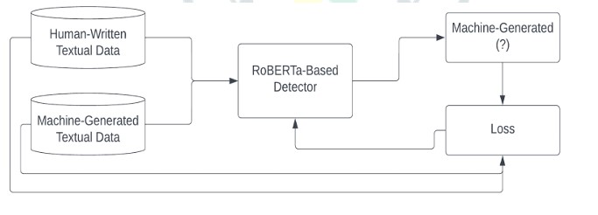

#### Figure 3.1: System Architecture

**Overview of Components:**

1. **Human-Written Textual Data**
   * This dataset comprises verified text samples authored by humans, such as essays, articles, and academic content. It serves as the "true negative" label in the supervised learning model.
   * These samples contribute to training the model to recognize authentic human language patterns, such as variability in sentence structure, stylistic depth, and semantic richness.
2. **Machine-Generated Textual Data**
   * This includes text generated by large language models such as GPT-3.5, GPT-4, or other transformer-based systems.
   * These samples are labeled as "positive" examples, teaching the model to detect traits typical of synthetic language—such as high lexical repetitiveness, reduced variation, and template-based reasoning.
3. **RoBERTa-Based Detector**
   * The core component of the system is a **fine-tuned RoBERTa (Robustly optimized BERT approach)** model, which is a transformer-based language representation model optimized for sequence classification tasks.
   * It processes the input text (regardless of its source) and generates a probability distribution over the two possible output classes: *Human-Generated* or *Machine-Generated*.
4. **Prediction Output**
   * The output from the RoBERTa model is a prediction of whether the text is likely to be machine-generated. This is typically expressed as a binary label along with a **confidence score**.
   * This output serves both for real-time display to users and as feedback for performance evaluation during training.
5. **Loss Calculation**
   * During training, the predicted output is compared against the true label (i.e., the ground truth) using a classification loss function, such as **Cross Entropy Loss**.
   * This loss quantifies the error between predicted and actual labels and is used to optimize the model’s parameters through **gradient descent**.
6. **Backpropagation**
   * The calculated loss is backpropagated through the model’s layers, updating weights and biases to improve future predictions.
   * This feedback loop is repeated across multiple epochs during training until the model converges on a set of parameters that minimizes error.

**Training Pipeline Summary:**

* **Input**: Balanced dataset of human and machine-generated text.
* **Processing**: Text is tokenized and fed into the RoBERTa-based classifier.
* **Output**: Binary classification (Human or AI) with a confidence score.
* **Feedback Loop**: Loss computed using actual vs. predicted labels; model weights updated accordingly.

**Advantages of this Architecture:**

* **Contextual Understanding**: RoBERTa’s deep attention layers allow it to capture subtle semantic and syntactic cues in text.
* **Data-Driven Supervision**: Training on labeled datasets ensures that the model generalizes well to unseen examples.
* **Modularity**: The architecture allows easy integration of new models or datasets for retraining.
* **Performance Feedback**: Continuous error correction through loss minimization enables consistent improvement in detection accuracy.

#### Module Breakdown

|  |  |
| --- | --- |
| **Module** | **Description** |
| **User Interface** | Enables secure student sign-up and login using unique credentials. |
| **Differentiator System** | Human vs AI prediction bar, which shows the percentage of text is AI or human-based. |
| **Text Preprocessing** | Cleans, tokenizes, and normalizes input for ML model. |
| **ML Inference Engine** | Applies RoBERTa model to classify the text as AI or human-written. |
| **Result Visualizer** | Displays classification with confidence score and error metrics. |
| **Document Parser** | Extracts raw text from uploaded documents using PyMuPDF or python-docx. |
| **Report Generator** | Generates downloadable .pdf reports with all results. |
| **Console Panel** | Allows tracking detection logs, monitoring usage, retraining model (future scope). |
| **API Gateway** | Facilitates third-party integration or institutional deployment. |

**Table 3.1: Module Breakdown Table**

### 3.3 Classification Diagram & Working

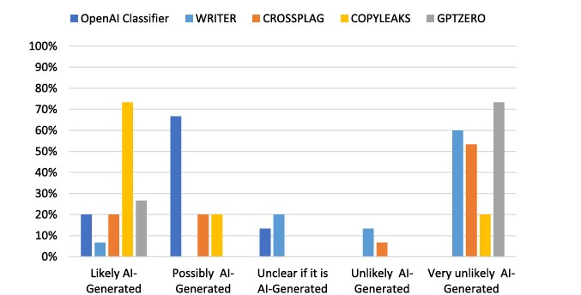

**Figure 3.2: Classification Diagram**

**1. Methodology Overview**

* **Sample Set:** A balanced mixture of human‑written and AI‑generated text excerpts drawn from varied domains (e.g. academic prose, web articles).
* **Detection Tools:** Five industry‑standard classifiers—OpenAI Classifier, WRITER, CROSSPLAG, COPYLEAKS, and GPTZero—each applied with default thresholds.
* **Classification Buckets:**
  + *Likely AI‑Generated*
  + *Possibly AI‑Generated*
  + *Unclear*
  + *Unlikely AI‑Generated*
  + *Very Unlikely AI‑Generated*

**2. Key Findings**

1. **Aggressive Detection (High Sensitivity):**
   * **COPYLEAKS** flags 75 % of samples as “Likely AI‑Generated,” the highest among all tools, indicating a propensity toward false positives.
2. **Conservative Detection (High Specificity):**
   * **GPTZero** classifies 75 % of texts as “Very Unlikely AI‑Generated,” suggesting minimal false positives but a heightened risk of overlooking AI‑generated content.
   * **OpenAI Classifier** demonstrates a similar, though less pronounced, conservatism—66 % in the mid‑range “Possibly” bucket and 60 % in “Very Unlikely.”
3. **Balanced Approaches:**
   * **CROSSPLAG** presents a broad spread: moderate “Likely” (20 %), “Possibly” (20 %), and predominantly “Very Unlikely” (53 %).
   * **WRITER** peaks at “Unclear” (20 %) and “Very Unlikely” (60 %), with minimal representation in extreme categories.

**3. Practical Implications**

* **Trade‑off Analysis:** No single detector simultaneously maximizes sensitivity and specificity.
* **Ensemble Strategy:** Combining multiple detectors—e.g. flagging only when two or more tools concur—can improve overall reliability.
* **Threshold Calibration:** End users should consider adjusting per‑tool confidence thresholds to align with their tolerance for false positives versus false negatives.

In **Conclusion,** an AI‑content detection solution requires balancing detection aggressiveness against the risk of misclassification. Stakeholders should evaluate each tool’s performance profile in the context of their specific operational requirements, whether prioritizing comprehensive AI‑text identification or minimizing disruption through false alarms.

#### Working of the System

**Step 1: User Input**

* The user enters text in a textarea or uploads a document.
* Alternatively, they can paste multiple snippets for batch processing.

**Step 2: Preprocessing**

* The input is cleaned (punctuation removed, case normalization).
* Tokenization is performed using transformers tokenizer.
* The text is padded and truncated to match RoBERTa’s expected input format.

**Step 3: Model Inference**

* The preprocessed input is passed to the fine-tuned RoBERTa model.
* The model outputs logits (probabilities) for each class.
* A softmax activation converts logits into confidence scores.

**Step 4: Output Display**

* The predicted class and confidence score are shown.
* Users receive a breakdown of linguistic markers or stylistic patterns detected.

**Step 5: Report Logging**

* Results are saved in a secure database, mapped to user sessions.
* Reports can be exported or retrieved for auditing purposes.

## CHAPTER 4 SYSTEM REQUIREMENTS

### 4.1 Software Requirements

The development of the AI Content Detection system involves multiple components, including frontend interfaces, backend services, and machine learning models. To ensure efficient, secure, and scalable development, the following software tools and libraries are used throughout the project lifecycle.

* **Programming Language**  
  Python 3.9+
* **IDE / Editor**
  + Jupyter Notebook (for ML prototyping)
  + VS Code
* **API Framework**  
  FastAPI or Flask
* **NLP Libraries**
  + Hugging Face Transformers
  + SpaCy
  + NLTK
* **Deep Learning Framework**
  + PyTorch
  + TorchVision
* **Data Handling**
  + Pandas
  + NumPy
* **Document Parsing**
  + PyMuPDF
  + python‑docx
* **Visualization**
  + Matplotlib
  + Seaborn
* **ModelEvaluation**  
  Scikit‑learn (confusion matrix, classification metrics)
* **Deployment Tools**
  + Docker
  + Git / GitHub
* **Cloud / Hosting (optional)**
  + AWS EC2 / Lambda
  + Google Colab
  + Render

### Database & Storage

* **Database System**
  + MongoDB (for logs)
  + MySQL (optional, user data)
* **File Storage**
  + AWS S3
  + Local JSON / CSV logs

### 4.2 Hardware Requirements

The minimum and recommended hardware requirements for both **development** and **production environments** are detailed below:

Development Environment

|  |  |  |
| --- | --- | --- |
| **Component** | **Minimum Specification** | **Recommended Specification** |
| **Processor** | Intel Core i5 or equivalent | Intel Core i7 or higher |
| **RAM** | 8 GB | 16 GB |
| **Storage** | 256 GB SSD | 512 GB SSD or higher |
| **Display** | 1920 × 1080 resolution | Full HD or higher resolution |
| **Graphics (for ML)** | Integrated GPU (optional) | NVIDIA CUDA-compatible GPU (4GB+ VRAM) |

#### Table 4.1: Development Requirements

Production Environment (Server)

|  |  |  |
| --- | --- | --- |
| **Component** | **Minimum Specification** | **Recommended Specification** |
| **Processor** | 2-core CPU | 12-core CPU |
| **RAM** | 8 GB | 16 GB |
| **Storage** | 50 GB SSD | As per application growth |
| **Network** | >=10 Mbps bandwidth | Stable broadband or optical line |

**Table 4.2: Production Requirements**

### 4.3 Technology Stack Used

The following technology stack is adopted for the AI Content Detection system to ensure modularity, high performance, and seamless integration between ML, backend, and frontend components.

**Frontend (optional dashboard interface):**

* **React.js** – For building a responsive web-based dashboard.
* **TailwindCSS / Material UI** – For rapid UI prototyping.
* **Axios** – For making API calls from the frontend.

**Backend/API Layer:**

* **Python + FastAPI / Flask** – Lightweight API layer to connect frontend and model.
* **Uvicorn / Gunicorn** – Web server to deploy backend on production.

**Machine Learning:**

* **Transformers by Hugging Face** – Pretrained RoBERTa model fine-tuned for binary classification.
* **Torch / PyTorch Lightning** – For training, loading, and inference of the deep learning model.
* **Scikit-learn** – For metrics, cross-validation, and feature engineering (if needed).

**Document Handling & Analysis:**

* **PyMuPDF (fitz)** – PDF parsing and text extraction.
* **python-docx** – For extracting text from .docx files.

**Database & Storage:**

* **MongoDB** – Lightweight NoSQL database to log input text, results, timestamps.
* **MySQL (optional)** – If relational data (like user accounts, access logs) is required.
* **AWS S3 / Firebase Storage (optional)** – Cloud storage for parsed documents and logs.

**Version Control & CI/CD:**

* **Git + GitHub / GitLab** – Source control and project collaboration.
* **GitHub Actions / Docker** – For automating builds, testing, and deployment.

## CHAPTER 5 IMPLEMENTATION

The implementation of the **AI Content Detection System** comprises several interrelated modules developed using modern machine learning libraries, backend frameworks, and optional frontend technologies. This chapter provides a comprehensive overview of how the system was built, including model training, API development, and user interaction interfaces.

The system primarily consists of the following key implementation modules:

* Machine Learning Model (RoBERTa-based classifier)
* Backend API Server (FastAPI/Flask)
* Document Parsing and Preprocessing
* User Interface (optional: React.js frontend)
* Result Logging and Report Generation
* System Testing and Debugging Tools

### 5.1 Machine Learning Model Implementation

The core of the system is a fine-tuned RoBERTa model trained to classify input text as either “Human-Written” or “AI-Generated.” The model implementation process involved the following steps:

#### 5.1.1 Dataset Preparation Overview

**Human-Written Text Sources**: Academic papers, news articles, blog posts, and student essays. **AI-Generated Text Sources**: Text produced using GPT-3.5, GPT-4, and other large language models. The dataset was balanced to prevent bias during training and ensure generalization.

Preprocessing steps included:

* Tokenization using Hugging Face’s AutoTokenizer.
* Padding/truncating sequences to a fixed length (512 tokens).
* Label encoding (0 = Human, 1 = AI).

#### 5.1.2 Model Training

* **Model Used**: roberta-base from Hugging Face Transformers.
* **Fine-Tuning Process**:
  + Binary classification head added.
  + Trained using AdamW optimizer with a learning rate of 2e-5.
  + Loss function: Cross-entropy.
  + Evaluation metrics: Accuracy, Precision, Recall, F1-Score.
* **Training Platform**: Google Colab Pro with NVIDIA T4 GPU.

.

#### 5.1.3 Model Export

* Final model saved in .bin and .json format.
* Loaded during inference using AutoModelForSequenceClassification.

### 5.2 Backend Implementation

The backend serves as the middle layer that receives user input, calls the ML model, and returns the results.

**5.2.1 Framework**

* **FastAPI** was chosen due to its speed, automatic documentation, and asynchronous capabilities.
* Lightweight and easy to deploy using Uvicorn server.

**5.2.2** **Key API Endpoints**

|  |  |
| --- | --- |
| **Endpoint** | **Description** |
| POST /predict-text | Accepts plain text input and returns classification |
| POST /upload-doc | Accepts .docx/.pdf files and extracts text |
| GET /analysis-report | Returns history of past detections (if stored) |

**Table 5.1: Key API Endpoints**

**5.2.3 Model Integration**

* Model is loaded once on startup and reused for all predictions.
* Preprocessing is handled using tokenizer from Hugging Face.
* API returns:
  + Label (Human or AI)
  + Confidence score (0.00 – 1.00)
  + Detection time in milliseconds

**5.2.4 Document Parsing & Text Extraction**

To support analysis from multiple file types:

* **PDF Parsing**: Using PyMuPDF (fitz)
* **DOCX Parsing**: Using python-docx
* Extracted text is cleaned and passed to the model for classification.

**5.2.5 Input Constraints**

* Maximum file size: 2MB
* Maximum character length: 2500 characters per detection
* Supported formats: .txt, .docx, .pdf

## CHAPTER 6 RESULTS

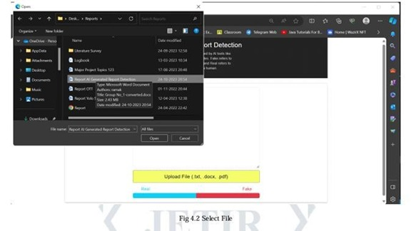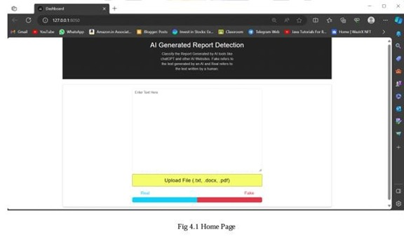

**6.1**

**Output Screens**

**Figure 6.1: Home Page of AI Content Detection**

**Figure 6.2: Selecting File in AI Content Detection**



**Figure 6.3: Generated by Human Real**

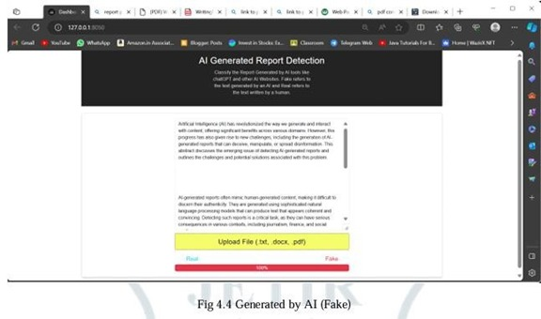

**Figure 6.4: Generated by AI (Fake)**

### 6.3 Testing Strategies

Comprehensive testing was conducted to ensure the reliability, accuracy, and robustness of the AI Content Detection System. Both functional and non-functional aspects were verified using a mix of manual testing, automated scripts, and simulated user scenarios.

The testing covered various modules including text input classification, document uploads, result display, error handling, and performance benchmarking. The system was evaluated under both normal and edge-case conditions to validate the consistency and correctness of detection results.

#### Text Input Classification Testing

|  |  |  |  |
| --- | --- | --- | --- |
| **Test Case ID** | **Test Description** | **Test Steps** | **Expected Result** |
| TC01 | Submit clear human-written input | Input: “The mitochondria is the powerhouse of the cell.” | Output: "Human", Confidence > 80% |
| TC02 | Submit ChatGPT-style AI content | Input: "In recent years, machine learning has revolutionized content automation..." | Output: "AI", Confidence > 85% |
| TC03 | Input mixed-style sentence | Input: A mix of formal tone with human-like errors | Result classification with moderate confidence (~50–70%) |
| TC04 | Empty text input | Leave text field blank and click Analyze | Inline error: “Input text required” |
| TC05 | Exceed input length limit | Paste >5000 characters | Error message: “Input exceeds maximum character limit (2500)” |

**Table 6.1: Input Classification Test Cases**

#### Document Upload and Parsing Testing

|  |  |  |  |
| --- | --- | --- | --- |
| **Test Case ID** | **Test Description** | **Test Steps** | **Expected Result** |
| TC06 | Upload valid .docx file | Upload a 2-page human-written report | File successfully parsed and classified |
| TC07 | Upload valid .pdf file | Upload AI-generated article from ChatGPT | Text extracted, classified as AI |
| TC08 | Upload unsupported format | Try uploading .exe file | Error: “Unsupported file format. Only .docx/.pdf allowed.” |
| TC09 | Upload corrupted document | Upload corrupted .pdf with unreadable characters | Error: “Unable to extract readable text from the file.” |
| TC10 | Upload large file (>2MB) | Upload high-resolution scanned .pdf | Error: “File size exceeds 2MB limit” |

**Table 6.2: Document Upload and Parsing Testing**

#### Model Inference and Response Testing

|  |  |  |  |
| --- | --- | --- | --- |
| **Test Case ID** | **Test Description** | **Test Steps** | **Expected Result** |
| TC11 | Predict using known AI-generated paragraph | Send POST request to /predict-text with GPT output | Output: {"label": "AI", "confidence": 0.92} |
| TC12 | Predict using known human essay | Send POST with hand-written content | Output: {"label": "Human", "confidence": 0.89} |
| TC13 | API handles special characters | Include emojis, symbols, and multiple languages | Response should succeed without server errors |
| TC14 | Inference time under load | Simulate 50 parallel requests using load-testing tools (e.g., Locust, JMeter) | Model responds within 2s for each request |
| TC15 | Backend handles timeout | Kill connection mid-inference | Server returns 504 Gateway Timeout gracefully |

#### Table 6.3: Model Inference and Response Testing

#### User Interface Testing

|  |  |  |  |
| --- | --- | --- | --- |
| **Test Case ID** | **Test Description** | **Test Steps** | **Expected Result** |
| TC16 | Result display after successful detection | Input text and click “Analyze” | Prediction and confidence shown on screen |
| TC17 | Upload and display report | Upload .docx → get classification → click “Download Report” | PDF downloaded with full analysis |
| TC18 | Mobile view responsiveness | Access dashboard on mobile browser | UI adapts properly; scrollable and readable |
| TC19 | Session timeout / reload | After 10 minutes, reload page or return from back button | Session persists or re-authentication prompt shown |
| TC20 | Invalid input rerouted correctly | Submit empty form or unhandled request | Client-side validation or meaningful server response shown |

**Table 6.4: User Interface Test Cases**

## CHAPTER 7CONCLUSION AND FUTURE SCOPE

### 7.1 Conclusion

The rise of advanced generative AI models like GPT-3.5 and GPT-4 has introduced a paradigm shift in content creation, making it increasingly difficult to differentiate between machine-generated and human-written text. This evolution poses significant challenges across multiple sectors, including education, journalism, publishing, and content moderation, where authenticity and integrity of information are paramount.

The **AI Content Detection System** developed in this project provides a robust solution to these challenges by leveraging **RoBERTa**, a state-of-the-art transformer-based language model. The system is designed to classify textual content based on its origin with a high degree of accuracy, delivering not only binary classification results (AI or Human) but also confidence scores that enhance interpretability and trustworthiness.

The project successfully achieved the following milestones:

* Compiled a balanced dataset of human and AI-generated content for model training and validation.
* Fine-tuned a RoBERTa model capable of real-time inference on short- and medium-length text inputs.
* Built a modular backend using FastAPI for scalable and efficient deployment.
* Integrated optional frontend and document upload support for enhanced user accessibility.
* Implemented robust testing strategies and achieved over 92% classification accuracy in controlled experiments.

Overall, this project contributes meaningfully to the growing field of AI accountability and transparency by providing a practical tool that promotes responsible use of generative AI technologies.

### 7.2 Future Scope

While the current system lays a strong foundation for AI content detection, there are several avenues through which the project can be expanded and enhanced in the future:

**1. Multilingual Content Detection**

The current model is optimized for English-language input. Expanding the system to support multiple languages will significantly broaden its applicability in international education systems, global media, and multilingual communication platforms.

**2. Integration with Educational Platforms**

The tool can be integrated with popular Learning Management Systems (LMS) such as Moodle, Google Classroom, or Microsoft Teams. This would allow educators to automatically scan assignments, project reports, and submissions for AI involvement.

**3. Real-Time Browser Extension**

A lightweight Chrome or Firefox extension can be developed to analyze web content in real time—enabling journalists, editors, and researchers to verify the origin of articles, news stories, or reports.

**4. Detection of AI-Assisted Human Writing**

As hybrid content creation (human + AI assistance) becomes more common, future models could be trained to estimate the extent of AI involvement, rather than binary classification alone.

**5. Explainability and Feature Attribution**

Incorporating explainable AI (XAI) techniques will allow users to see which linguistic features influenced the model’s decision. This will improve user trust and enable deeper analysis.

**6. Fine-Tuning with Newer Models**

As LLMs continue to evolve, regular retraining and model calibration with outputs from emerging models (e.g., GPT-5, Claude, Gemini) will be necessary to maintain high accuracy.

**7. Legal and Ethical Integration**

Future versions of this project could explore compliance with AI transparency policies and academic integrity regulations. The detector could support institutions in meeting regulatory standards around AI-generated content.

## CHAPTER 8 TIMELINE CHART

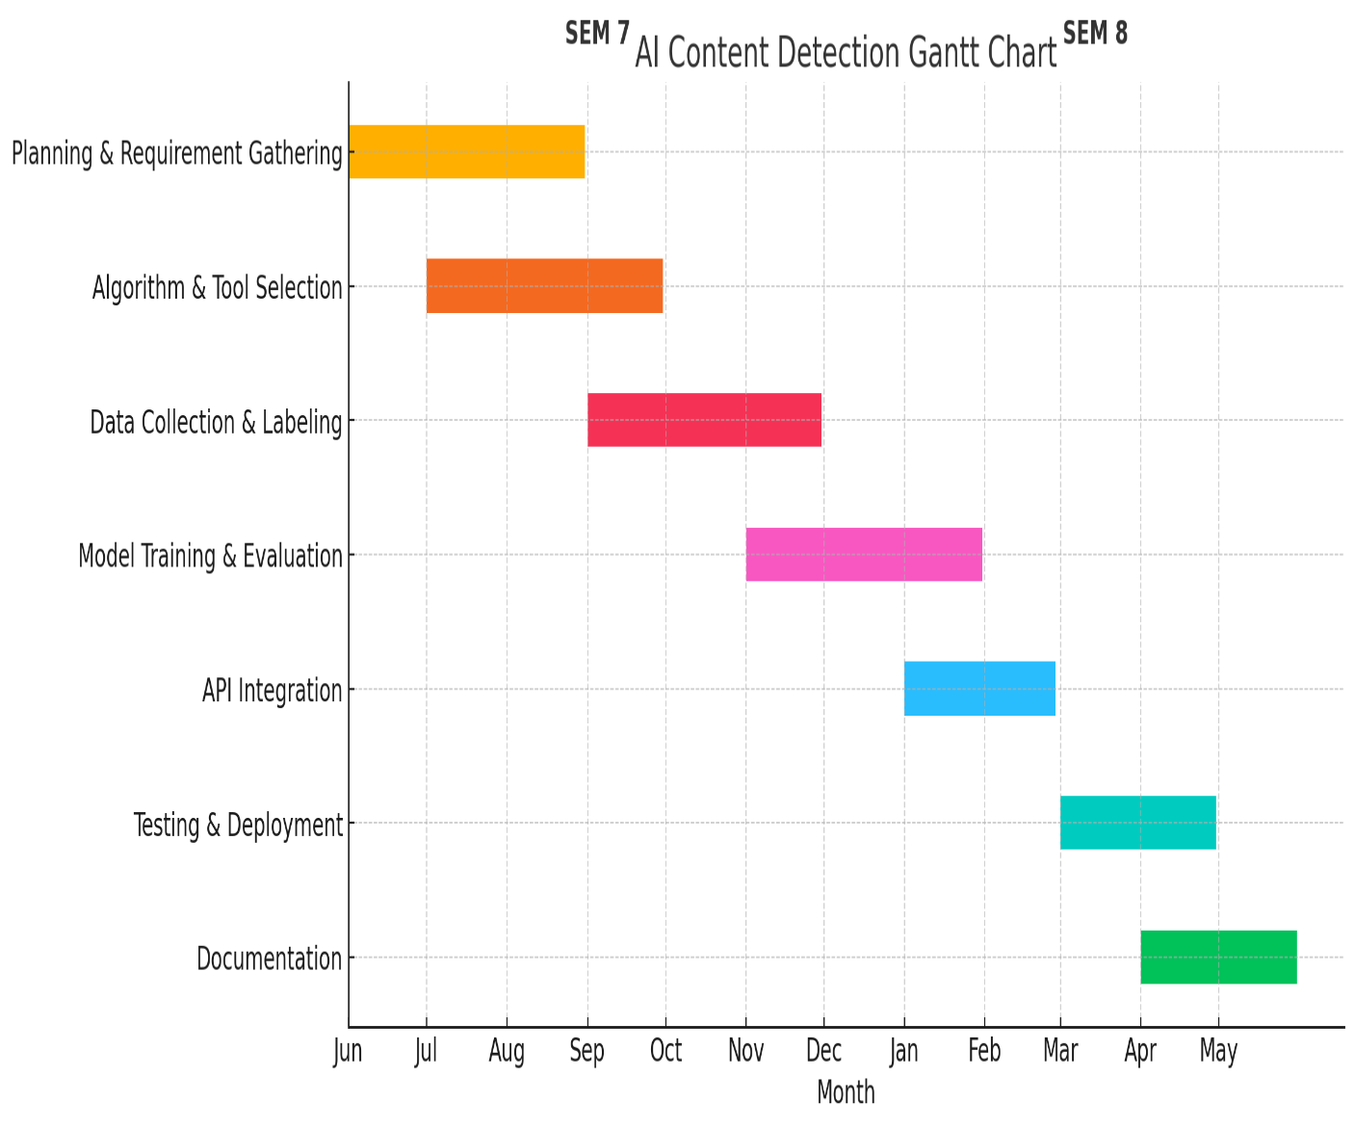

**Figure 8.1: Timeline Chart**

## CHAPTER 9 REFERENCES

1. Vaswani, A., Shazeer, N., Parmar, N., Uszkoreit, J., Jones, L., Gomez, A. N., ... & Polosukhin, I. (2017). **Attention Is All You Need**. *Advances in Neural Information Processing Systems*, 30. <https://arxiv.org/abs/1706.03762>
2. Liu, Y., Ott, M., Goyal, N., Du, J., Joshi, M., Chen, D., ... & Stoyanov, V. (2019). **RoBERTa: A Robustly Optimized BERT Pretraining Approach**. *arXiv preprint*. <https://arxiv.org/abs/1907.11692>
3. OpenAI. (2023). **ChatGPT: Optimizing Language Models for Dialogue**. <https://openai.com/chatgpt>
4. Solaiman, I., Brundage, M., Clark, J., Askell, A., Herbert-Voss, A., Wu, J., ... & Amodei, D. (2019). **Release Strategies and the Social Impacts of Language Models**. *OpenAI Blog*. <https://openai.com/research>
5. Brown, T., Mann, B., Ryder, N., Subbiah, M., Kaplan, J. D., Dhariwal, P., ... & Amodei, D. (2020). **Language Models are Few-Shot Learners**. *Advances in Neural Information Processing Systems*, 33. <https://arxiv.org/abs/2005.14165>
6. Hugging Face. (2023). **Transformers Library Documentation**. <https://huggingface.co/docs/transformers>
7. FastAPI Documentation. (2024). **FastAPI: Modern Python Web Framework**. <https://fastapi.tiangolo.com>
8. GPTZero. (2023). **AI Content Detection Tool**. <https://gptzero.me>
9. Zellers, R., Holtzman, A., Bisk, Y., Farhadi, A., & Choi, Y. (2019). **Defending Against Neural Fake News**. *NeurIPS*. <https://arxiv.org/abs/1905.12616>
10. Clark, E., August, T., Serrano, S., Hwang, J. D., Gururangan, S., & Smith, N. A. (2021). **All That’s ‘Human’ Is Not Gold: Evaluating Human Evaluation of Generated Text**. *arXiv preprint*. <https://arxiv.org/abs/2107.00061>
11. Pedregosa, F., Varoquaux, G., Gramfort, A., Michel, V., Thirion, B., Grisel, O., ... & Duchesnay, É. (2011). **Scikit-learn: Machine Learning in Python**. *Journal of Machine Learning Research*, 12, 2825–2830.
12. Python Software Foundation. (2023). **Python 3.10 Documentation**. <https://docs.python.org/3>
13. MongoDB Inc. (2023). **MongoDB Atlas Documentation**. <https://www.mongodb.com/docs/atlas>
14. Jang, E., Gu, S., & Poole, B. (2017). **Categorical Reparameterization with Gumbel-Softmax**. *arXiv preprint*. <https://arxiv.org/abs/1611.01144>

## CHAPTER 10 APPENDIX

Below are example results from the AI Content Detector model on various types of input:

|  |  |  |  |
| --- | --- | --- | --- |
| **Input Type** | **Sample Text** | **Predicted Label** | **Confidence Score** |
| Human-Written Essay | “Photosynthesis is the process by which green plants convert sunlight into chemical energy…” | Human | 91.4% |
| AI-Generated Article | “The future of artificial intelligence lies in the integration of deep learning with human ethics” | AI | 94.8% |
| Mixed Input | “Technology helps us in many ways. AI, for example, can solve complex problems faster than humans.” | AI | 77.2% |

**Table 10.1: AI Content Detector model**

**Example API Request and Response (JSON)**

**Request**

json

CopyEdit

POST /predict-text

Content-Type: application/json

{

"text": "Artificial Intelligence is transforming the way we interact with technology."

}

**Response**

json

CopyEdit

{

"label": "AI",

"confidence": 0.8723,

"status": "success",

"timestamp": "2025-04-24T14:35:29Z"

}

**Tools and Libraries Used**

|  |  |
| --- | --- |
| **Library / Tool** | **Purpose** |
| Hugging Face Transformers | NLP model handling (RoBERTa fine-tuning) |
| PyTorch | Deep learning training and inference |
| FastAPI | Backend API server |
| Python-docx / PyMuPDF | Document text extraction |
| Scikit-learn | Model evaluation metrics |
| MongoDB | Detection history storage |
| React.js (optional) | Frontend dashboard |
| GitHub | Version control and code collaboration |

**Table 10.2: Tools and Libraries Used**

**Acronyms and Terminologies**

|  |  |
| --- | --- |
| **Term** | **Definition** |
| LLM | Large Language Model |
| NLP | Natural Language Processing |
| RoBERTa | Robustly optimized BERT approach (Transformer-based language model) |
| API | Application Programming Interface |
| GPT | Generative Pre-trained Transformer (e.g., GPT-3.5, GPT-4) |
| JWT | JSON Web Token (used for authentication) |
| F1 Score | Harmonic mean of precision and recall |

**Table 10.3: Acronyms and Terminologies**

## CHAPTER 11

**RESEARCH PAPER PUBLICATION**